Assignment 14

##Inserting, Deleting, and Changing Field Values.
1) Write a command that puts the following values, in their given order, into the
salespeople table: city – San Jose, name – Blanco, comm – NULL, snum – 1100.
Ans--
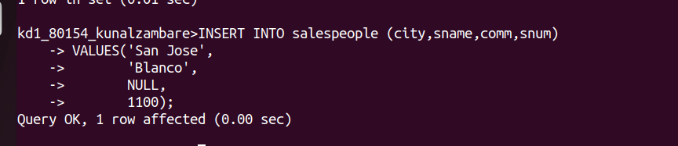

2) Write a command that removes all orders from customer Clemens from the
Orders table.
Ans--
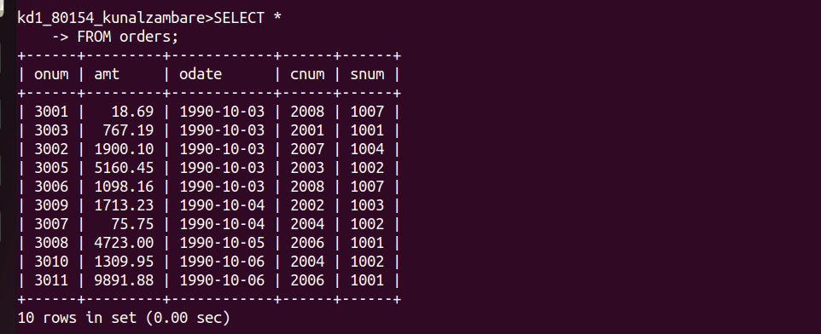
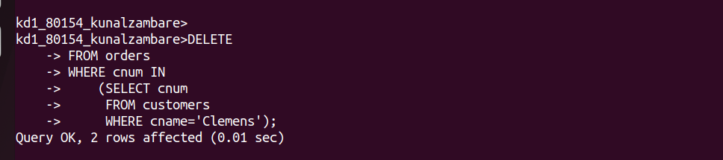

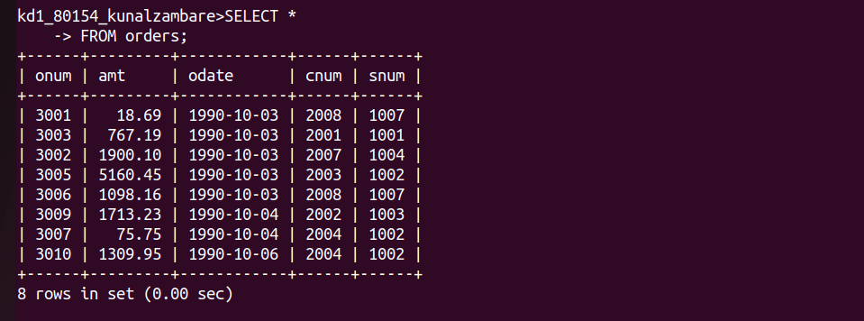
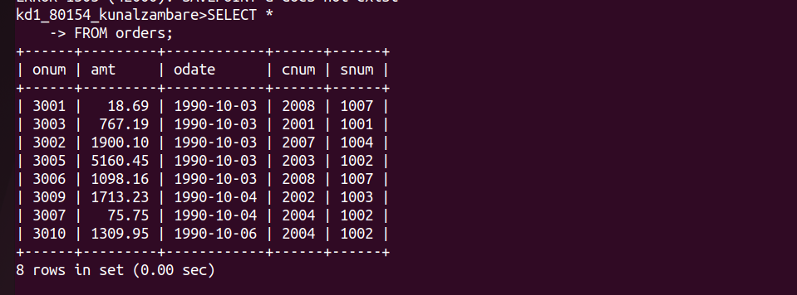

3) Write a command that increases the rating of all customers in Rome by 100.\
Ans--
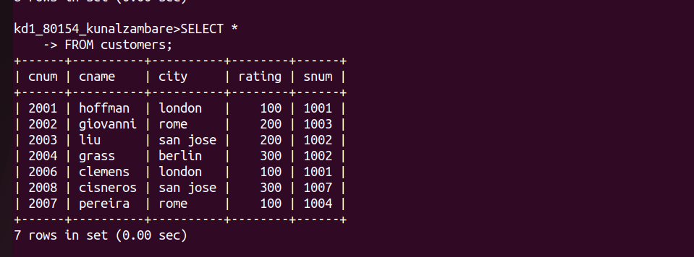

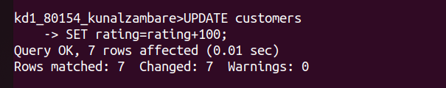

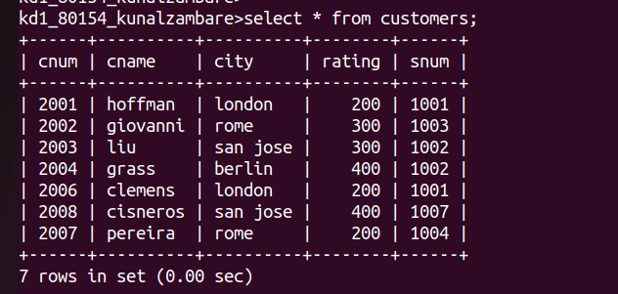

4) Salesperson Serres has left the company. Assign her customers to Motika.
Ans--
